Super store dataset review

Insights:

>Highest sale by subcategory is for phones
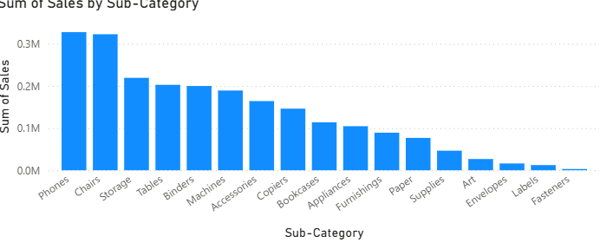
>Highest sale by category is technology based products

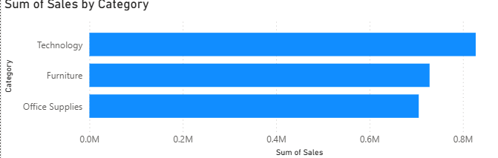

>highest segment by sales is done by Consumer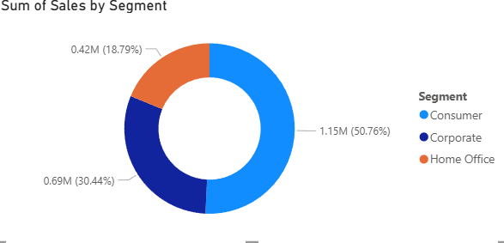

>Total sum of sales is 2.26 million

